**HAMILTON, CICELY (1872-1952)**

Cicely Hamilton, lesbian actor, author, and women’s suffrage activist, is best-known for her plays *Diana of Dobson’s* (1908), exposing exploitation in the retail trade, *How the Vote Was Won* (1909), a suffrage comedy co-authored with Christopher St. John, and *A Pageant of Great Women*, which raised consciousness about women’s history in productions across Britain from 1909 to 1912. Hamilton also wrote non-dramatic works, including the political tract *Marriage as a Trade* (1909) and the novel *William, An Englishman* (1919), which was inspired by her experience of wartime France. Hamilton’s prolific writing career reflects her wide-ranging interests, political commitments, and sense of public duty; her plays exemplify the intersection of feminism and theatre in the early twentieth century.

After a brief stint as a teacher, Hamilton turned to the stage and writing, and all these skills led to her national profile in the British women’s suffrage movement. A founding member of the Women Writers’ Suffrage League and a prominent member of the Pioneer Players, she collaborated with the lesbian theatre director Edith Craig on *How the Vote Was Won* (1909) and *A Pageant of Great Women* (1909) and wrote the words to the legendary suffrage anthem that became ‘The March of the Women’, for which the lesbian composer Ethel Smyth wrote the music.

Beyond her theatrical work, Hamilton took part in branch politics for the Women’s Freedom League and engaged in public political debate, notably with G. K. Chesterton in 1911. After enfranchisement, her political interests were broadly egalitarian, involving campaigning for equal pay and education about contraception. Her writing career flourished and diversified. In the 1930s, she published nine volumes of travel writing that together formed a comparative analysis of national identities and cultural practices. Committed to campaigning for equality and wide social reform, Hamilton developed an international perspective on modern life.

**List of Works**

*Diana of Dobson’s* (1908)

*Marriage as a Trade* (1909)

*A Pageant of Great Women* (1909)

*How the Vote Was Won* (1909) (with Christopher St. John)

*William, An Englishman* (1919)

*Life Errant* (1935)

**References and Further Reading**

Blodgett, Harriet. (1990) ‘Cicely Hamilton, Independent Feminist’, *Frontiers* 11 (2-3): 99-104

Cockin, Katharine. (2005) ‘Cicely Hamilton’s Warriors: Dramatic Reinventions of Militancy in the British Women’s Suffrage Movement’, *Women’s History Review* 14 (3-4): 527-42.

Stowell, Sheila. (1992) *A Stage of Their Own: Feminist Playwrights of the Suffrage Era*, Ann Arbor: University of Michigan Press.

Whitelaw, Lis. (1990) *The Life & Rebellious Times of Cicely Hamilton*, London: Women’s Press.

**Katharine Cockin, University of Hull**

**Recommended Illustrations**

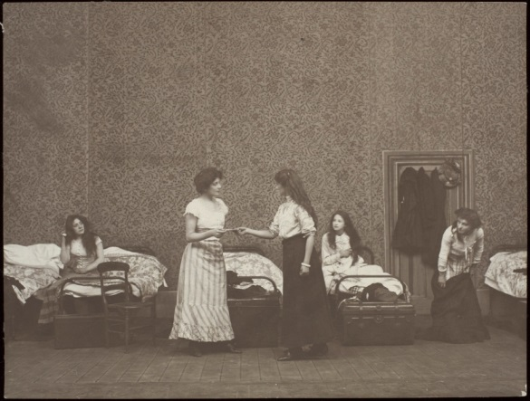

**The opening scene of *Diana of Dobson’s*, Kingsway Theatre, London, 1908.**

[Photo © V&A Images / Theatre and Performance Collections

Theatre and Performance Collections, Victoria and Albert Museum, London. The image is on the internet in connection with an exhibition at the Tate Gallery:<http://www.tate.org.uk/art/research-publications/camden-town-group/william-rough-walter-sickert-and-contemporary-drama-r1104370> ]

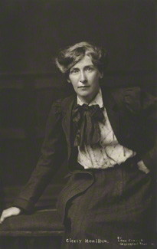

**Cicely Hamilton**

[Available at the National Portrait Gallery: <http://www.npg.org.uk/collections/search/portrait/mw121590/Cicely-Mary-Hamilton-nee-Hammill?LinkID=mp86027&search=sas&sText=cicely+hamilton&OConly=true&role=sit&rNo=0> ]